St Michael’s Houses SNS, Ballvmun

Notification regarding the Board of Management’s review of the Child Safeguarding Statement

To: The Parents

The Board of Management of St. Michael’s House SNS wishes to inform you that:

  - The Board of Management’s annual review of the school’s Child Safeguarding
Statement was completed at the Board meeting of 9/11/2022.

  - This review was conducted in accordance with the “Checklist for Review of the Child

Safeguarding Statement” published on the Department’s ‘website

Signed
Date

Chairperson, Board of Management
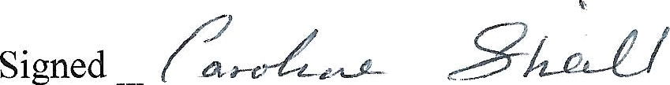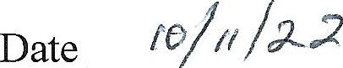

Principal/Secretary to the Board of Management

